Trauma / MVC / Pancreatic Injury
Stem: In the trauma bay, A 35-Year-old female, involved in a head on MVC. ATLS initiated. You do primary and secondary surveys. IV access established, she is talking to you and is complaining of pain primarily in her chest and abdomen.
Vitals: HR of 130, BP 150/90, RR 18 and sating 99% on room air.
She is noted to have a seatbelt sign and. Her chest wall is mildly tender, her abdomen is peritonitic with severe epigastric tenderness.
Medical and Surgical history are unremarkable.
FAST / CXR are negative.

How are you going to manage this patient?
- ATLS
- Trauma panel (Labs are significant for WBC 16.0, Hgb 12.2, CMP is normal, and amylase is 300, lactate 1.0.
- CT scan shows a small amount of free fluid around the left upper quadrant and lesser sac, as well as a Grade 4 splenic laceration.
What is your differential diagnosis?
- Known splenic injury.
- Pancreatic Injury
- Perforated viscus (small bowel or stomach)
After CT scan, her BP trends down to 80/40, HR 140.
- Transfuse blood products (start with 2 units PRBCs)
- Ex.lap
  - Open / Explore
  - Pack 4 quadrants (Blood pressure responded to transfusion)
  - Splenectomy
  - Explore
Splenectomy was uncomplicated, hemostasis achieved, patient is hemodynamically stable.
You notice mild contusion of the pancreatic body, you can’t see obvious duct injury? What would you do?
Place Darin
You place a drain and conclude your operation, patient is closed, no packs left.
On POD 2 you notice the drain is putting > 350 cc , serosang. Your junior resident is asking you if they can obtain labs from the drain output, would you like to order specific labs?
Amylase from drain: > 2 times upper limit of normal
Next day drain is with higher output , what would you like to do?!
- MRCP with secretin stimulation for evaluation of main pancreatic duct (ERCP is an acceptable alternative, but risk of worsening pancreatitis in trauma patient): MRCP negative
- Consider octreotide.
- Repeat CT in 4-6 weeks?
What If persistent drainage , now a fistula? ERCP / Stent
What if when obtained MRCP earlier, it showed main pancreatic duct disruption?! ERCP/ Stent
ERCP attempted, Due to the patient’s anatomy, multiple attempts at pancreatic ductal cannulation were unsuccessful and the procedure was aborted. The patient continues to have high output of the LUQ drain despite being on octreotide How would you manage?

Ex lap for distal pancreatectomy.
- Attachments of spleen will already have been mobilized thus mobilize splenic flexure more if improved visualization needed.
- Open entirety of gastrocolic ligament.
- Mobilize tail of pancreas to confluence of SMV/Splenic vein and transect pancreas.
- Sharp division or division with energy device with oversewing of duct and gland. +/- oversewing .
- Can cover with omentum

BURN
Stem: A 47 y/o male is brought to the ED by EMS after being evacuated from a bedroom fire, started while he was smoking in his bed.
Upon evaluation he is awake and conversive but appears confused.
He is noted to have 60% TBSA burns to his upper torso, sparing only his lower extremities. His nasal hair is singed and he has a productive cough with a hoarse voice.
HR- 115, RR- 30, BP – 95/50, Temp – 37C, SpO2-100%.

Additional Workup or Studies:
CMP, CBC, carboxyhemoglobin, lactate

What are you concerned about?!:
- Airway compromise with an upper airway inhalation injury
- Development of decreased pulmonary compliance with circumferential burns to the torso
- Carbon monoxide poisoning
- Hypothermia
- ARDS/multisystem organ failure
- Compartment syndrome in extremities or abdomen

What would you like to do now?
- Intubate – 100% FiO2
- Serial carboxyhemoglobin levels
- Establish adequate IV access and initiate fluid resuscitation using parkland formula:
2-4 ml/kg/%TBSA burn using LR. First ½ within 8 hours of burn.
Second ½ in the next 16 hours
- Place a foley to monitor resuscitation. Goal 30 – 50 cc/hr

Scenario: Patient is 100 kg, received 60% TBSA burn. He arrives four hours after his burn and has received a total of four liters of crystalloid. How would you manage his fluids at this point

Parkland: 100 kg * 60% *2ml/kg = 12L in first 24 hours, 6L in first 8 hours. Patient has already received 4L 🡪 500 cc/hr for the remainder of the first 8 hours.

Scenario: Patient has been transported to the ICU and is being mechanically ventilated. You get a call from respiratory therapy that his peak airway pressures have increased to 35. What are you concerned about?

- Abdominal compartment syndrome.
- Restrictive physiology due to thoracic eschars)

What would you do?
- check bladder pressure
- Perform escharotomy of thorax

Describe
- Escharotomy of the thorax
- Vertical incision bilaterally between mid-clavicular line and mid axillary line.
- Connected by transverse incision x 2
- Bronchoscopy to evaluate degree of inhalational injury for prognostication and treat potential mucus plugging

What is the ARDS/vent management?
- Low tidal volume (4-6 ml/kg)
- Peak pressures <30
- Permissive hypercapnia (ph >7.2)
- Increase PEEP
- Consider proning.

Scenario 3: Patient is going to require skin grafting. Now he is on tube feeds. What is the nutrition/caloric need?

25 kcal/kg +40 kcal/%TBSA, protein 1.5 g/kg +3 g/%TBSA.

Scenario 4: 65 y/o male cement worker presents after cement has spilled through his shirt on his chest and he continued to work in the sun for the next 6 hours but noticed a terrible burning sensation over the area at the end of his shift. HR 90, BP 120/80, RR 15, Temp 37.2, what would you do?

- Call Poison control to obtain further recommendations and verify acid vs alkali
- Determine alkali burn – liquefactive necrosis.
- Begin burn resuscitation.
- Large volume lavage with water until pH <8, may require operative debridement.
- May require skin graft once wound has stabilized.

Incarcerated Femoral Hernia
Stem: 56 yo female presents to the emergency room with 18 hour history of nausea, vomiting, abdominal distension. Notes that she is otherwise healthy and was working in her garden yesterday and began to have pain in her right thigh radiating down the front of her leg. Thought it was a muscle strain so laid down for a couple hours but was awakened overnight by a feeling of nausea and abdominal pain and came to the emergency room.
PMH: HTN
PSH: None
Physical exam
- Afebrile
- Abdomen moderately distended, diffusely tender without rebound or guarding, no masses, + BS
- Rectal: Normal tone, no mass, GUAIC -
- Extremities: Firm tender mass with erythema at right superomedial thigh
Labs: WBC 11.4, Hgb 12.6, electrolytes K 3.3, otherwise normal
Imaging:
- CXR normal
- KUB: c/w dilated small bowel with multiple air fluid levels
What is your Differential Dx?:
- SBO due to
  - Hernia
  - Malignancy
  - IBD
  - Gallstone Ileus
  - Intussusception
  - Adhesions (less likely since no prior surgery)

What Would you like to do?
- Obtain CT
CT scan notable for findings c/w SBO with transition point posterior at right inguinal ligament with loops of bowel noted on superomedial right thigh

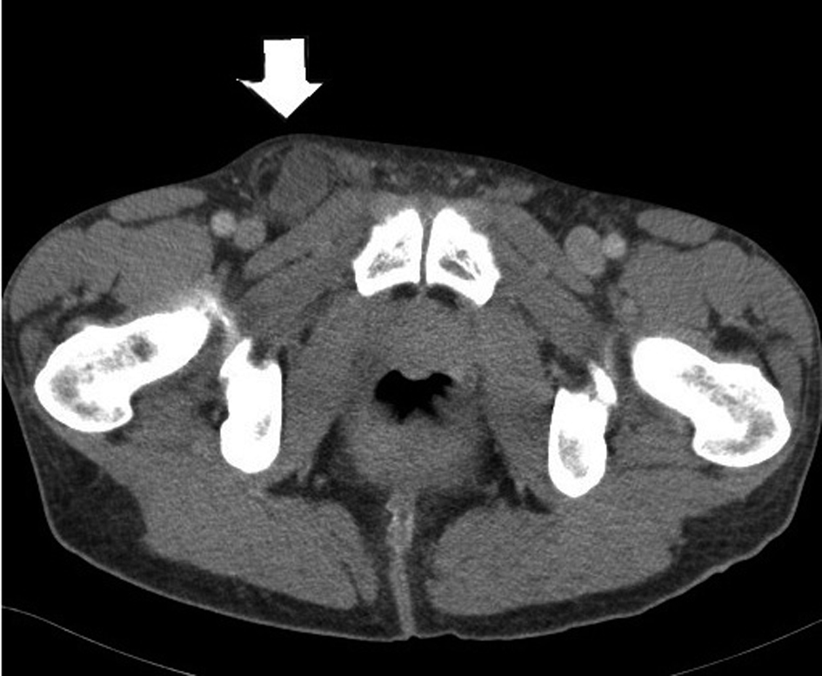

What is your diagnosis? Femoral hernia with Incarceration
What is your plan?
- Laparoscopic TAPP or TEPP
  - If attempt laparoscopically... ultimately unable to reduce
Open repair
  - Must describe opening inguinal floor / inguinal ligament to access femoral hernia / reduce

Open Lichenstein
- Oblique skin incision two fingerbreadths superior to inguinal ligament, carried through subcutaneous tissue
- External oblique fascia is identified and incised along direction of fibers
- Isolate cord structures from hernia sac
- Transect hernia sac (ensuring no sliding hernia) or reduce contents back intraabdominally
- Polypropylene mesh secured to pubic tubercle medially, inguinal ligament inferiorly, rectus sheath/internal oblique superiorly
- Reapproximate external oblique

  - Hernia repair plan if bowel ischemic? Tissue repair – McVay
    - A RLQ incision is made and the external oblique aponeurosis is opened through the external ring. Care should be taken to preserve the ilioinguinal nerve. Cooper's ligament is dissected free.
    - A relaxing incision should be made to reduce tension from this tissue repair. The relaxing incision should extend from the just above the pubis superiorly in the plane of fusion of the external oblique aponeurosis and the anterior rectus sheath.
    - The hernia sac is dissected free, excised and then closed.
    - Preperitoneal tissues are closed with a running absorbable suture.
    - Interrupted sutures are then placed between the transversus abdominis and Cooper's ligament, transitioning to the femoral sheath, superior laterally, allowing the spermatic cord to exit through the newly created internal ring.
    - The external oblique is closed.

EQ2 Perforated Appendicitis
Stem: You see a 45y male in the ER complaining of 5 days of abdominal pain. Pain was initially periumbilical but now is diffuse. For the past 3 days, he has had nausea, vomiting, and fevers. He presents now as he could no longer tolerate oral intake.
Vital signs: Bl. Pr 139/97, HR 118, Temp 39.2°C, RR 19.
Abdomen is nondistended and he has tenderness to palpation in the RLQ with focal rebound tenderness and voluntary guarding.
No PMH or PSH
WBC 18000, Creatinine 1.8

What is your differential diagnosis (Resident should recognize delayed presentation)
- Perforated appendicitis
- IBD related enterocolitis
- Perforated Meckle’s
- Right sided diverticulitis
- Perforated malignancy

What would you like to do?
- CT A/P
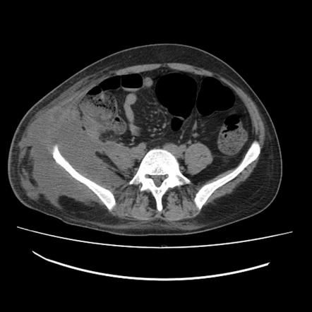

- Fluid bolus, hydration
- Blood cultures, UA
- Broad spectrum Abx.

How are you going to manage this patient?

- Admission
- Continue resuscitation / hydration/ antibiotics.
- IR drainage
(Treatment depends on the extent of the inflammatory process. Though patients with evidence of perforated appendicitis without a large abscess may benefit from appendectomy at the time of presentation. Howeverthis patient has evidence of a large amount of inflammation and free fluid in the RLQ, immediate surgical intervention may do more harm than good. In this setting, appendectomy is associated with a significantly higher rate of complications)

Scenario continues:
Patient gets IR drain next day, WBC improves the day after so as the rest of the labs, pain improves and you advance patient diet, bowel function returns and patient is discharged home, he comes to see you in the clinic and you remove the drain. He comes to see you, now 6 weeks later.
Describes some residual discomfort but not like how it was, you obtain new CT, no residual abscess, now what?

- Plan for a colonoscopy, Describe….
  - Resident should plan to do the colonoscopy themselves, remember to bowel prep the patient and describe steps.

Scenario Continues:
You perform the colonoscopy and apart from 4 mm adenomatous polyp at the sigmoid colon, coloscopy was normal to the cecum, appendiceal orifice seen.

Patient still with RLQ discomfort what would you offer?

Interval appendectomy.

Can you list indications for interval appendectomy?
- Recurrent appendicitis
- Persistent RLQ pain
- Fecalith
- Age over 40 years, and symptoms concerning for malignancy

You take the patient to the OR for laparoscopic appendectomy, during the procedure you decide to open due to adhesions, you make an incision to open at McBurney’s point,
Describe how to perform open appendectomy in general

- Skin incision at McBurney’s point or point of maximal tenderness.
- Open external oblique aponeurosis and bluntly separate internal oblique and transverse abdominis muscles.
- Incise peritoneum.
- Identify appendix and deliver into operative field.
- Divide mesoappendix.
- Place purse-string suture around base of appendix.
- Clamp crush base of appendix and ligate and divide appendix at its base.
- Invaginate appendiceal stump into base of cecum.
- Close peritoneum, fascia, and

